**Naïve Bayes Algorithm**

This is a more probabilistic algorithm, based on playing with conditional probability. We will use it to analyse text in emails and speeches. It is easy to implement and quick to train.

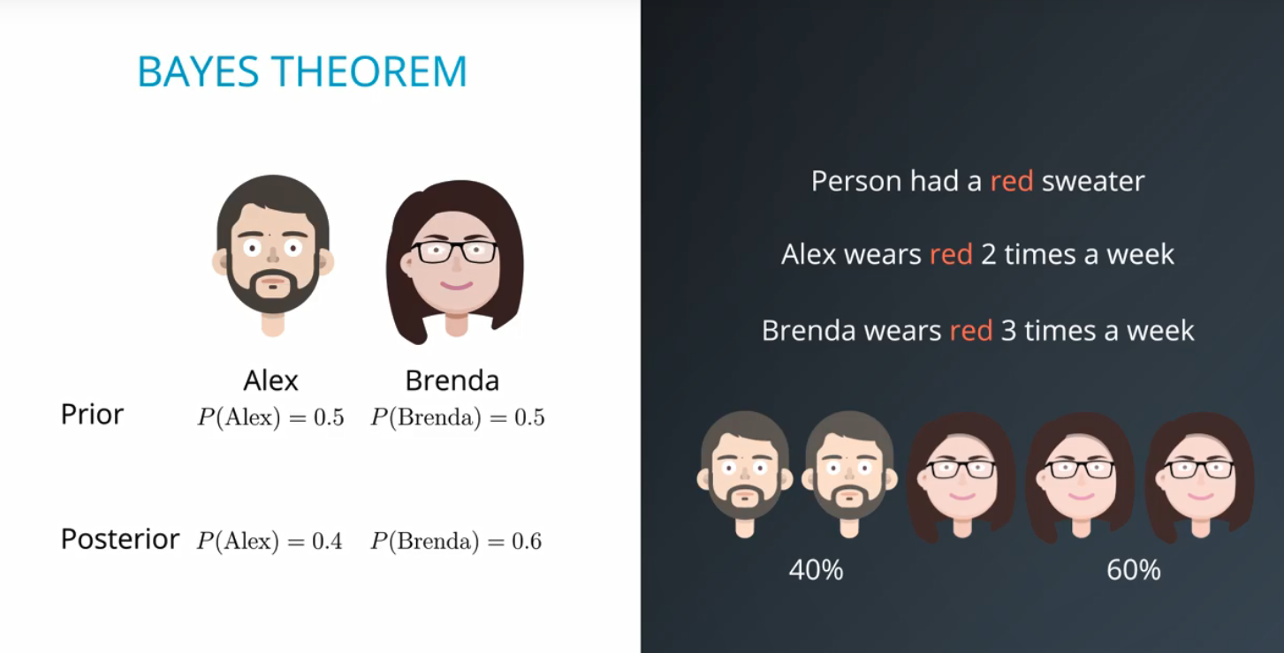

Main idea of Bayes Theorem helps us switch from what we know to what we infer. We would know the probability of an event A. Then we take the probability of R given A. Bayes theorem helps us get the probability of A given R. The theorem can get a lot more complex…

If we have the following we can use Bayes theorem to figure our probability of person being Alex given we know it was a red sweater and probability of it being Brenda given we know it was a red sweater:

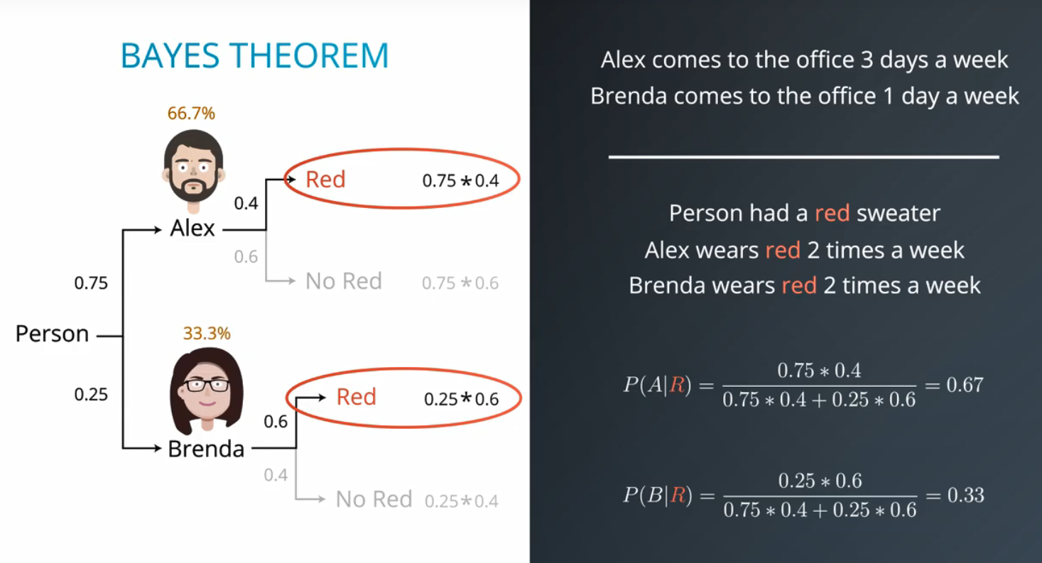

To generalise these:

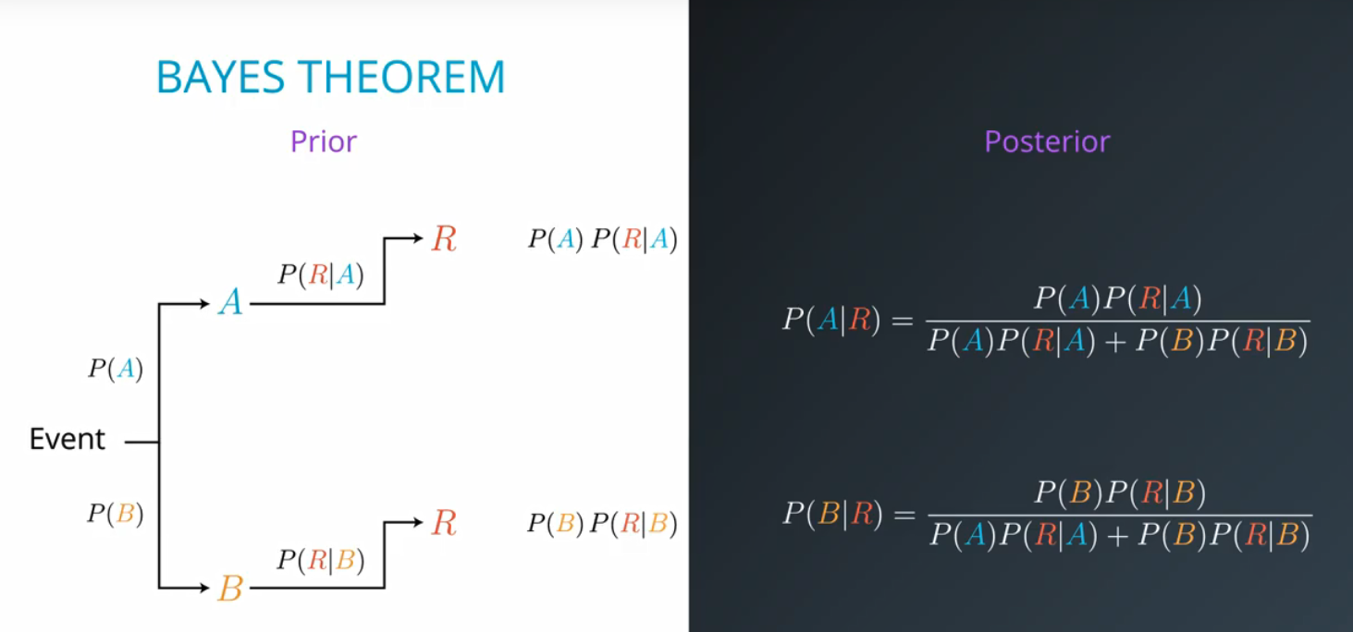

Application of Bayes Theorem, if we go to a doctors and they have a test that has 99% accuracy to say if you are sick. So for every 100 patients that are sick the test will correctly diagnose 99 of them. Also for every 100 patients that are healthy the test will correctly diagnose 99 of them. We also know that only 1 out of every 10000 people have the disease.

We are diagnosed as sick – what is the probability of us actually being sick? We will see that it’s actually a very low probability using Bayes Theorem:

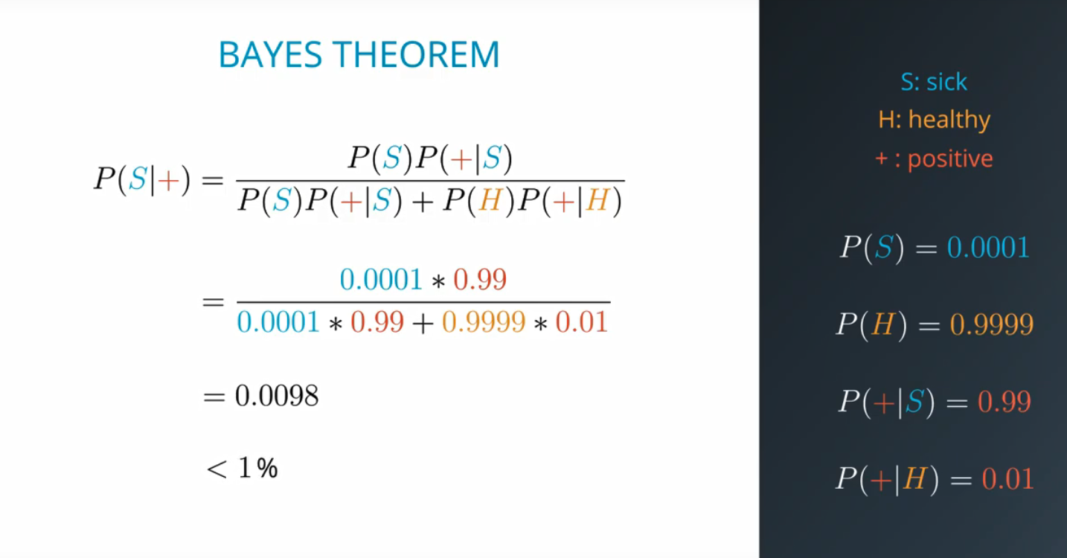

Breaking this down to a tree we can see:

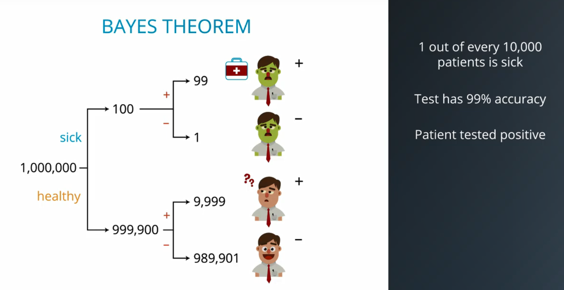

Because we know we tested positive we only look at the occasions where it tested positive:

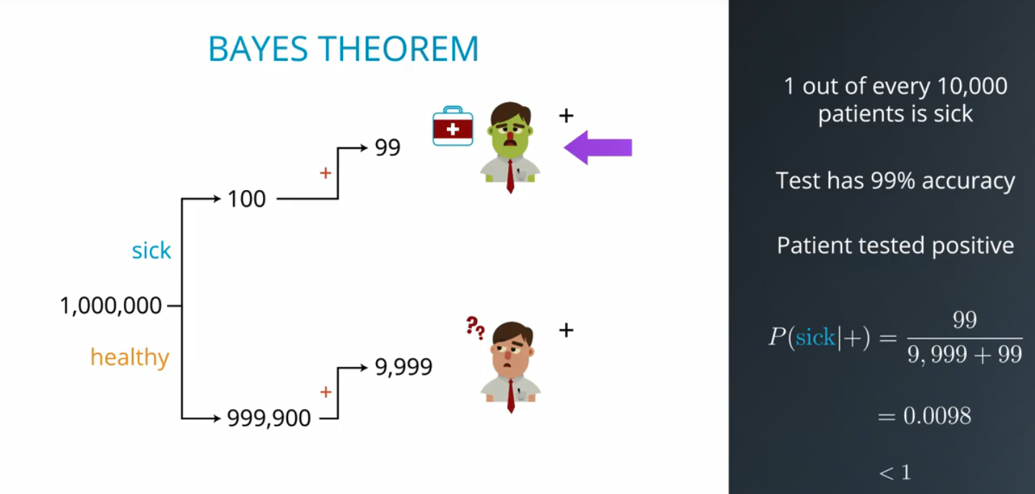

This is a perfect example of getting false positives which is a huge issue in real life scenarios:

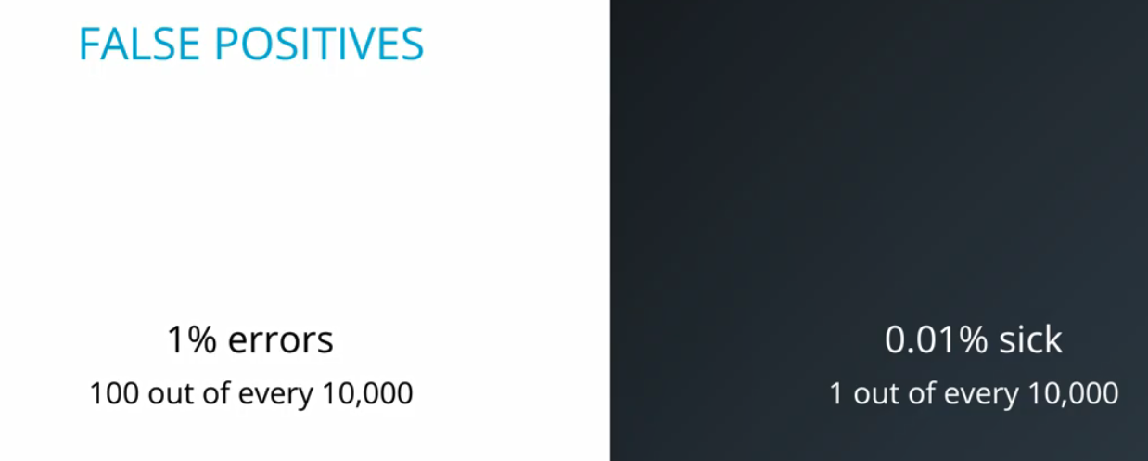

**Bayesian Learning**

The main principal of Bayesian Learning is that we are going from what is known to what is inferred, such as the below:

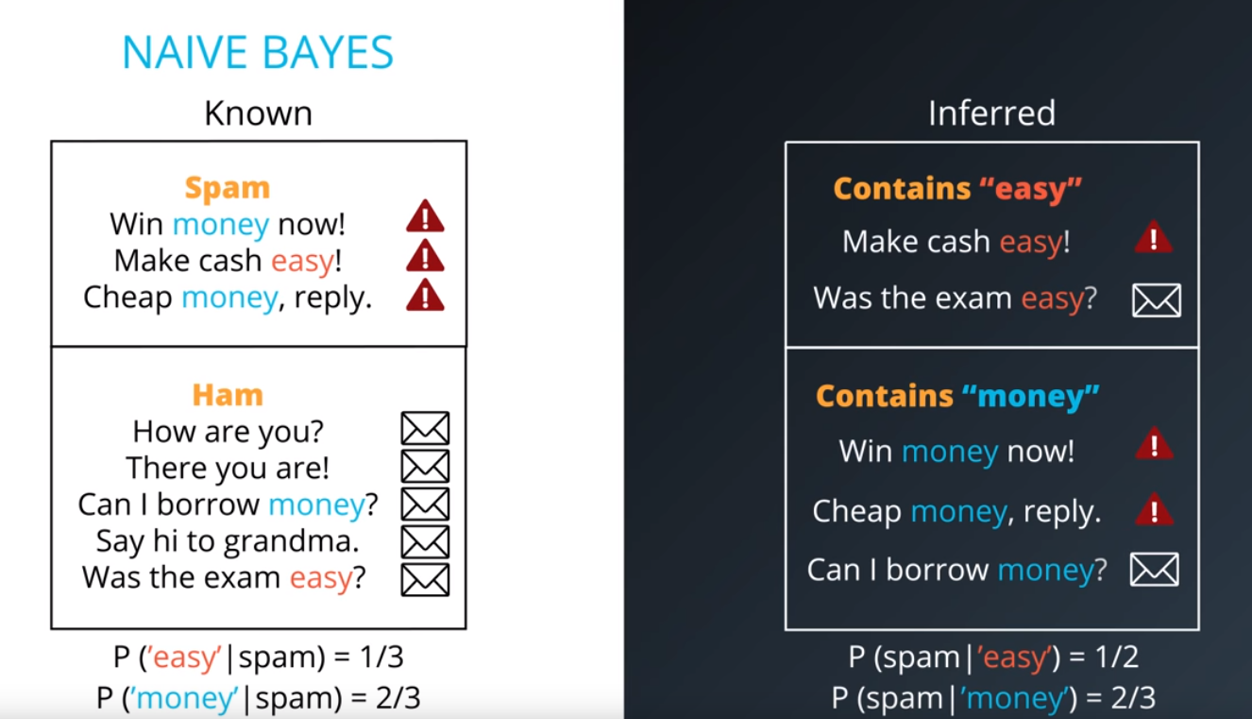

If we want to see the probability of an email being spam given it has the word “easy we could do the following based off of the data we have:

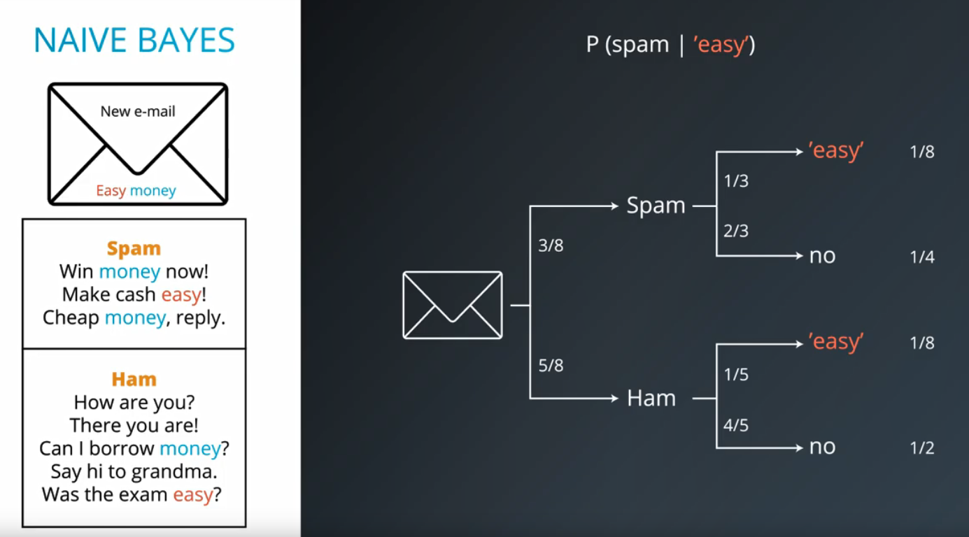

And the only look at the occasions where the email contains the word “easy”. These are both 1/8 so we normalise it up and it’s 50-50 as to whether it would be spam or not. These are the posterior probabilities.

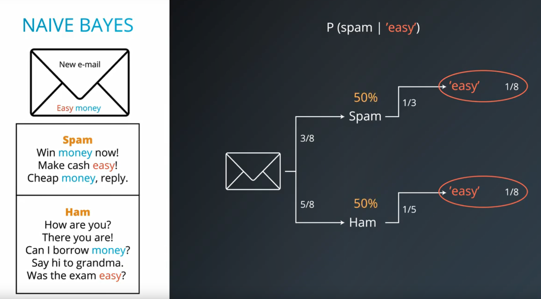

Similarly with money we would have:

